Section I: Physical Fitness
#1) We have a carved out 2 designated stretching areas from our office spaces. Anyone can visit the areas to stretch away. We also have yoga mats, an exercise ball, a foam roller, and exercise bands ready to use.
#2) We have continued to rotate encouraging and funny pics in our stairwell from the ground floor to the staff room to encourage stair walking.
#3) We sent the office ergonomics self-assessment sheet home. Since we have not been working in our usual office space, we knew it was still important to have an ergonomic space in our home as best as we could do.
#4) Due to Covid, we are not able to go for group walks or have a fun, team exercise time. However, we have come up with ways to continue being physical as a team and cheer each other on. We did a Fit February accountability challenge. I’ve included the details of the challenge and the before and after pictures of the calendar.

Fit February Board
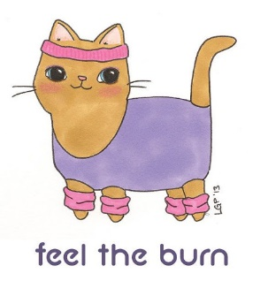
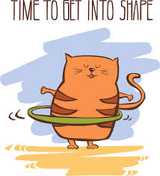
FIT FEBRUARY
We all have different fitness goals and routines. Pre-pandemic a lot of us took fitness classes, went to the gym, or had a group of workout buddies. Part of what is missed by not being able to partake in these activities, is the accountability. If you feel you are struggling with accountability in your everyday fitness, let’s join together in a February challenge. There will be a large calendar hanging in Tech Services with a pile of stickers. Every day you complete YOUR version of a workout or fitness routine, add a sticker to the day. Do this every day you feel good about whatever you accomplished related to your fitness. These things can include any and everything that is important to you to accomplish your fitness goal – running, rowing, walking, yoga, swimming, eating, pilates, weight lifting, cycling, etc. Rest days count as well. Neal Andrews said it best, “Rest is where the magic happens.”
Let’s fill this calendar with stickers!!!
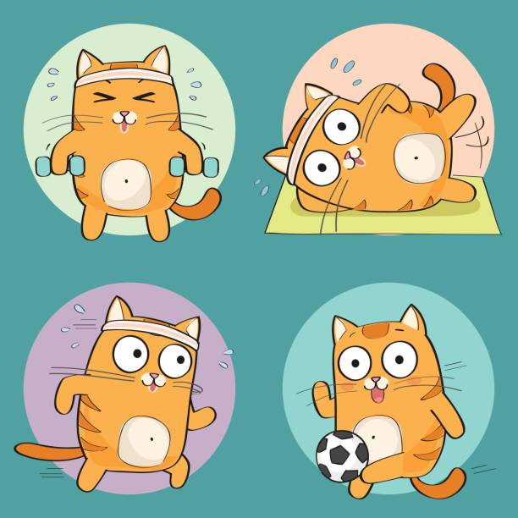
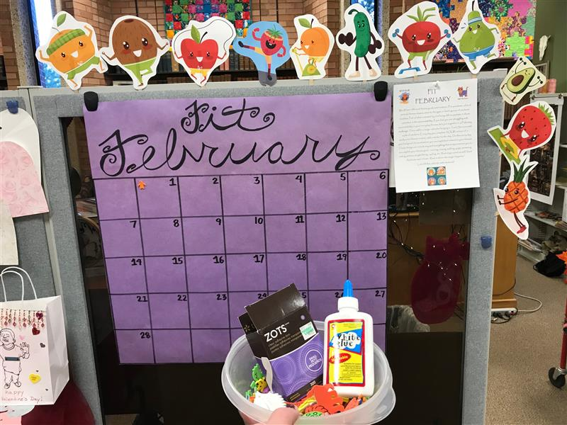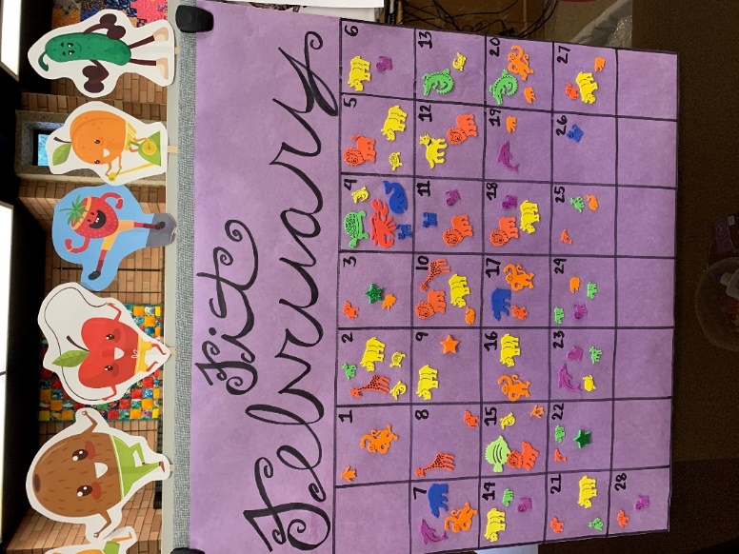
We also have utilized Teams for Wellness Wednesdays, where we come together virtually as a group. Sometimes we follow a little routine of office stretches or another time we found a YouTube video to follow. No matter if you are in the office or at home, it gets you standing and moving. The person who leads that week always challenges you to incorporate at least one new move/stretch into your daily routine.
And of course, we always band together in the Limeade team challenges.
#5) We are still following the Healthy Meetings Criteria.

Nutrition
#4) We have no control on what goes into the vending machines or how the snacks are labeled. All we can do is try to choose the best option out of it.

Culture
#1) Yes, our MUS Wellness Champion is Chandra Shaw
#2) When we were all together a year ago, our Library Director loved to take walking meetings with you. I am sure when we are back together again, this will continue to take place, especially with summer on the horizon.
#3) Since we have been working from home, many of the team members are going on walks around their neighborhood. Some are even doing online yoga sessions.
#4) Library director has always been supportive of wellness activities.
#5) We post our wellness announcements near the mailboxes. However, since we have not been together all that much, most of our announcements are landing in our Teams chat.
#6) Yes, we do.
#7) Several of us have been through the training, but we have not renewed the certification. Because of Covid, it has been difficult to find any training sessions being offered.
#8) It’s located in the connecting hallway between the Library and the Liberal Arts building.
#9) Yup, we are.
#10) While we don’t have a designated area, a couple of our offices are very discreet in location. We would be more than willing to offer them up for a nursing mother.
#11) Yes, it is.
#12) Due to Covid, there have only been online webinars to see. However, you know that in the future, we will be more than happy to offer a space in the library for a wellness event. We love them!
#13) The last on-campus group volunteer opportunity was a year ago for World Kindness Day, which we all participated in.
#14) We have viewed these from our homes or offices, but we always make sure to remind each other of upcoming webinars.
# 15) How have we maintained our social life as a library through Covid? Here’s how!
Campus cleanup/University Day: Since it was cancelled and we were all working from home at that time, we picked up trash throughout our own neighborhoods. We met on Teams and talked about the weirdest thing you found.

Pour Some Gravy on Me around Thanksgiving time. Each staff member made a hand turkey like we did in elementary school. They were outstanding. We then asked the University community to Take a Hand and Write Something Positive On It and pin it to the board.

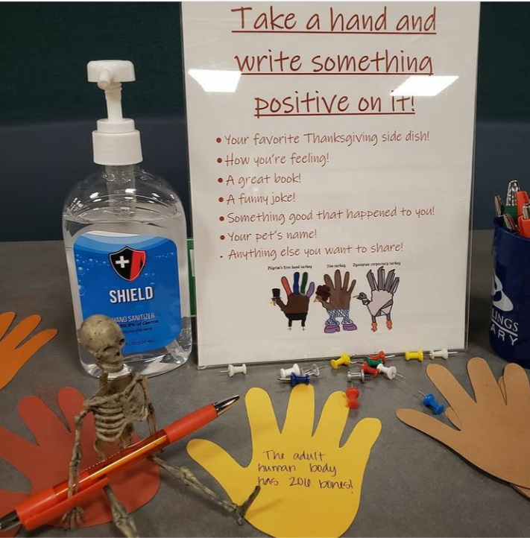

Annual Gingerbread Structure Competition. We all constructed our structures from home. We brought them in for the students to vote for their favorite one.
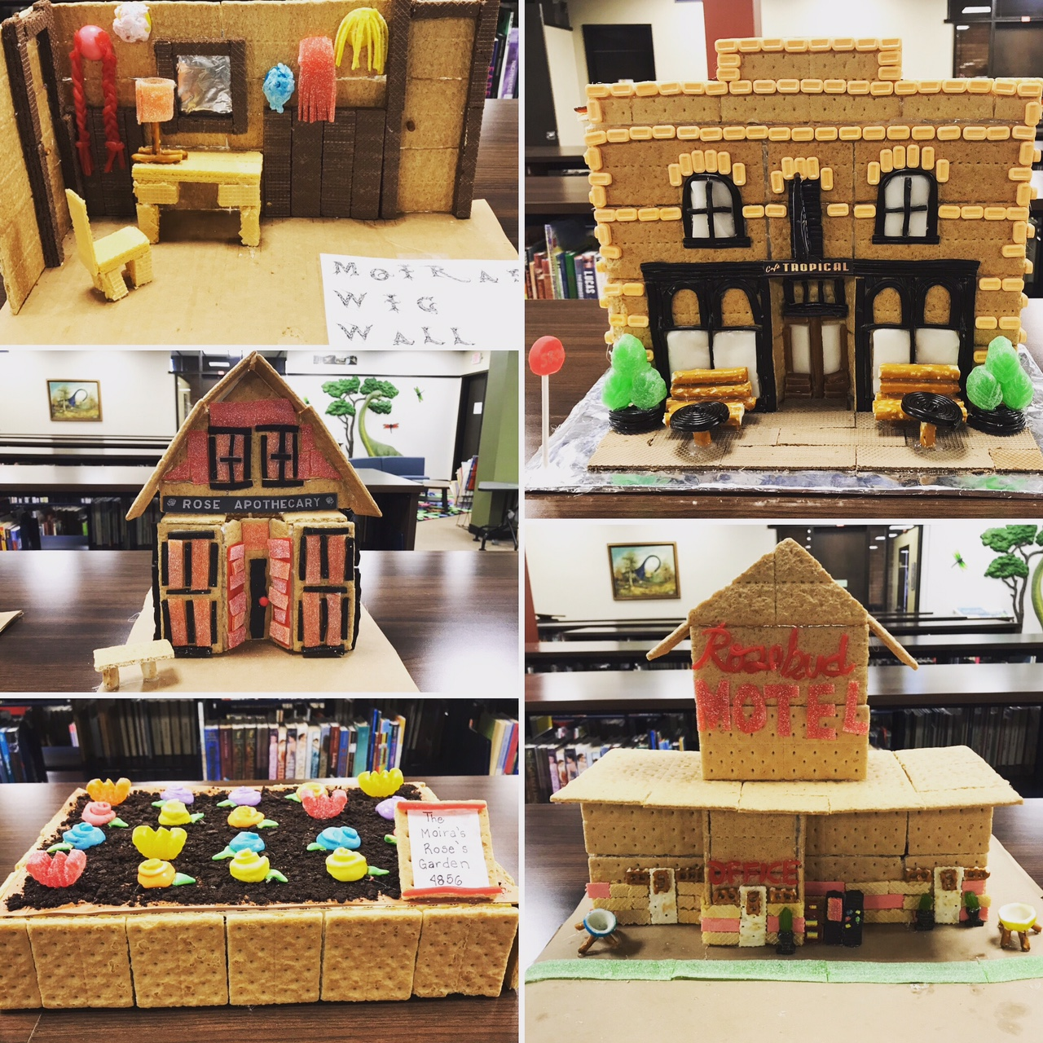

Spread Love Not Germs Valentine’s Day Celebration. Reminiscent of an elementary school Valentine’s Day party, we all decorated bags. They were so unique and fun to make and fill with cards and treats. Then came the surprise of what was in your bag!

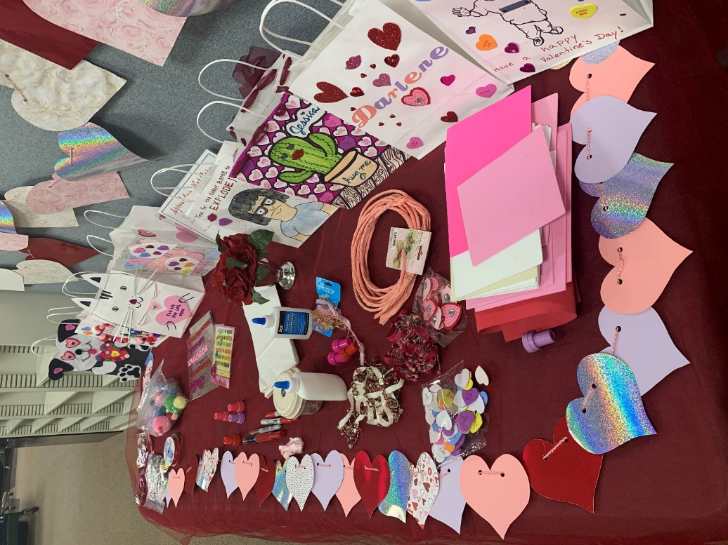
Galentine’s Day, our creative team of Jessica and Sam, made the Leslie Knope Compliment Generator. We asked folks to pick two adjectives and one noun to create a funny compliment. We loved the compliments so much, we added it to our motivating stairwell.
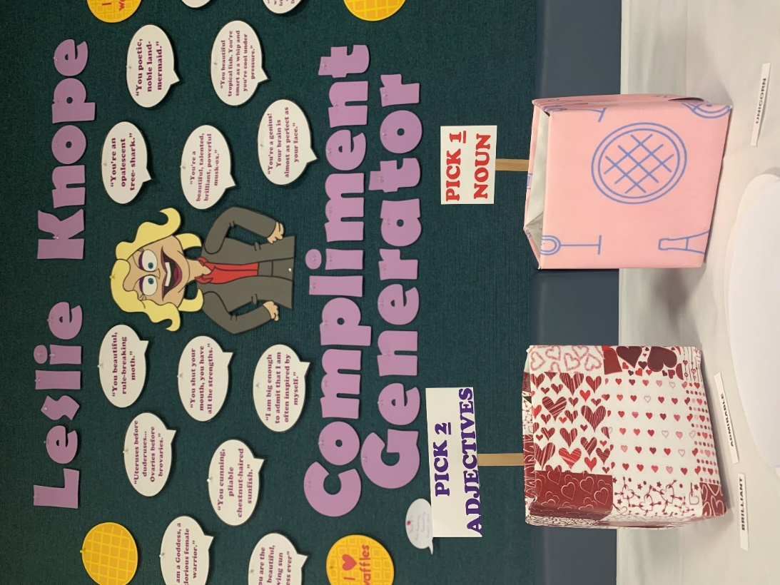

#16) A member of our team is on the Safety Committee. When she has information for us, it is included in our weekly update emails, which have taken the place of our in-person meetings.

Part 2
The past year has been challenging for all of us due to the Pandemic. Not only did we want to stay supportive as a team but also to our community. So, when we were all sent home, we joined in sharing our support by putting hearts in our windows for our health care workers and bears in the windows for the children as they walked their neighborhood. We also joined in the Howling for Health Care Workers at 8pm.
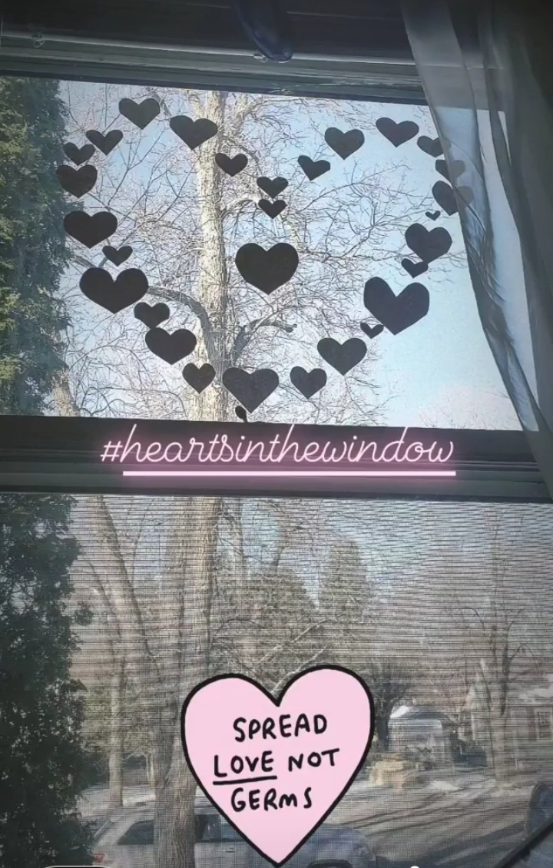

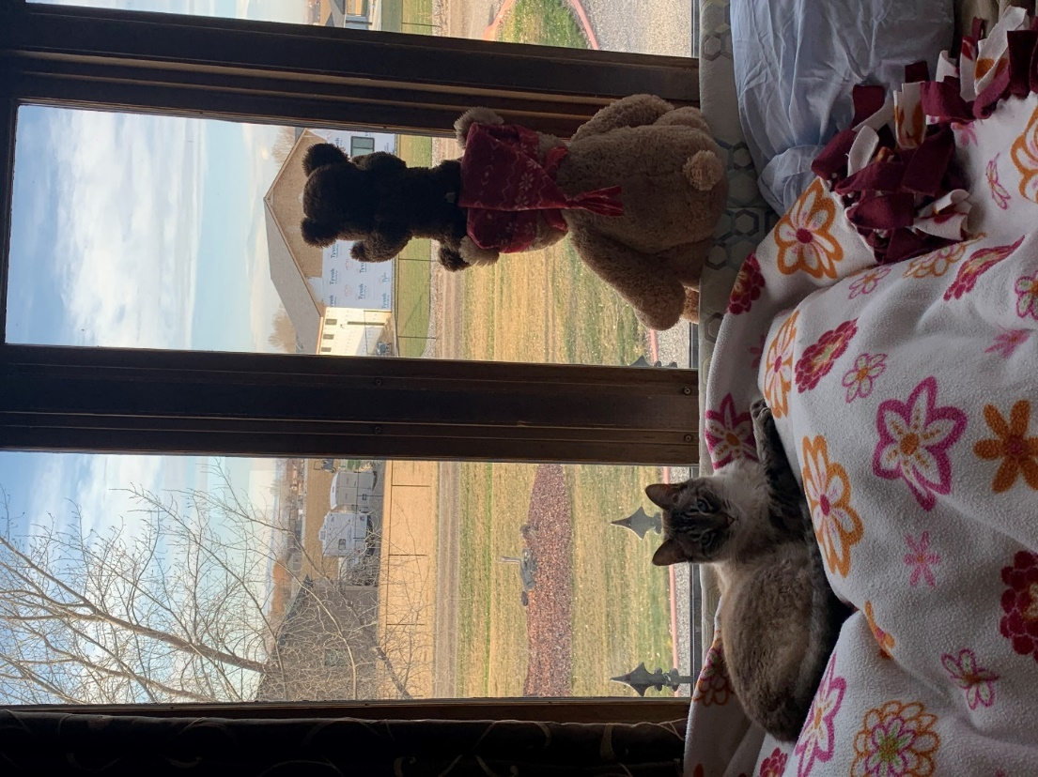
We have found creative ways to still be a team. Right away, we started using Microsoft Teams as a way to communicate with each other through video, chat, and instant messaging. This allowed us to stay connected and supportive through these tricky days. We have all felt the fatigue of Covid, but we have found ways to keep our spirits up.
In Teams, we started with a chat group called Tell me Something Good. We were all feeling overwhelmed with the situation of the world, and we all were seeking to hear something good. So this was and still is the place where you can share anything positive that you have heard, seen, or done.
Since we were unable to travel because of Covid restrictions, we started Take me Somewhere Tuesdays. We would share pictures or souvenirs of places we had been.
We also video chatted in a weekly Coffee Break.

The fun continued in Teams with shared pictures of Christmas Past and Spirit Fridays. We started to wear our MSU Billings gear on Fridays, and we would share a pic.
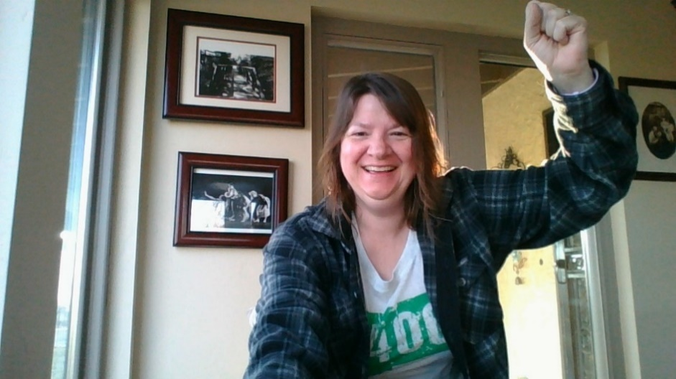



We would go on fun, picture-sharing tangents to bring our spirits up; such as WFH (Work from Home) Coworkers, which were our pets. They demonstrated just how helpful they could be.
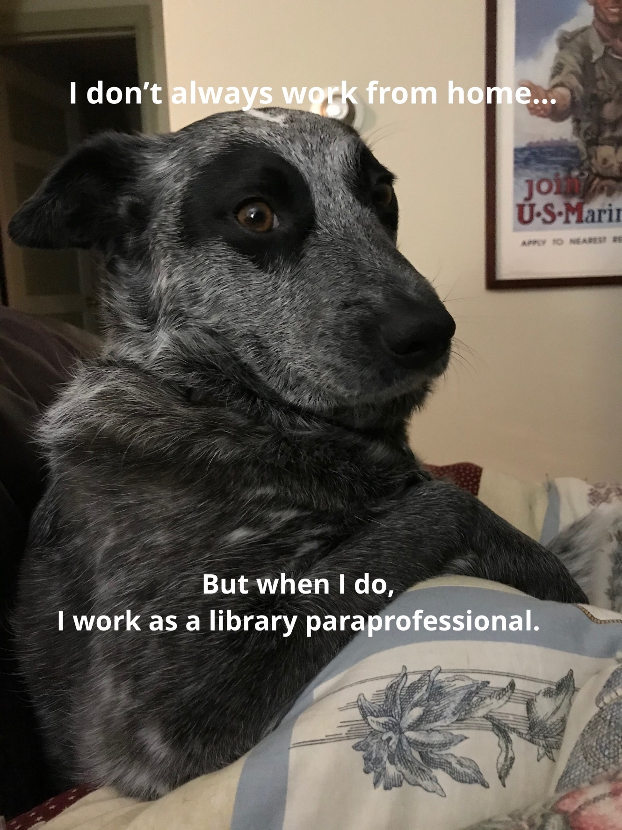

We love our plants! We have been adopting people’s plants into the library. Not only have we used up all the windows on the main floor, we asked staff and students to help give them their own unique names.
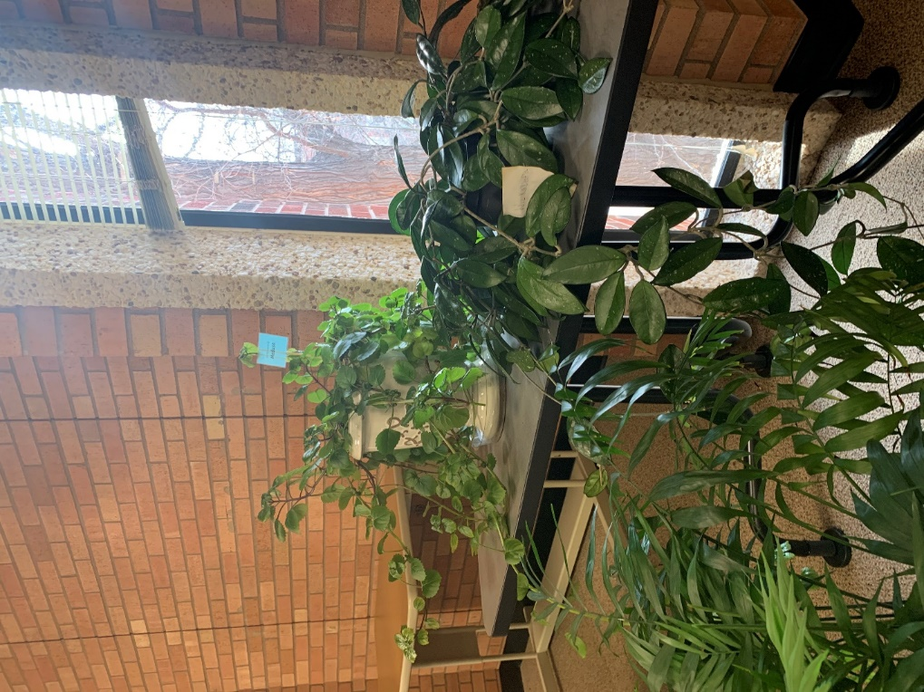

Jessica and Sam kept our spirits up in the library by decorating our Christmas Tree in different themes. Whenever you go by the mail area, you always get a smile on your face. It is a ray of sunshine in your day.
Halloween: Chandra Shaw, Sam Thatcher, and Jessica Torgerson-Lundin
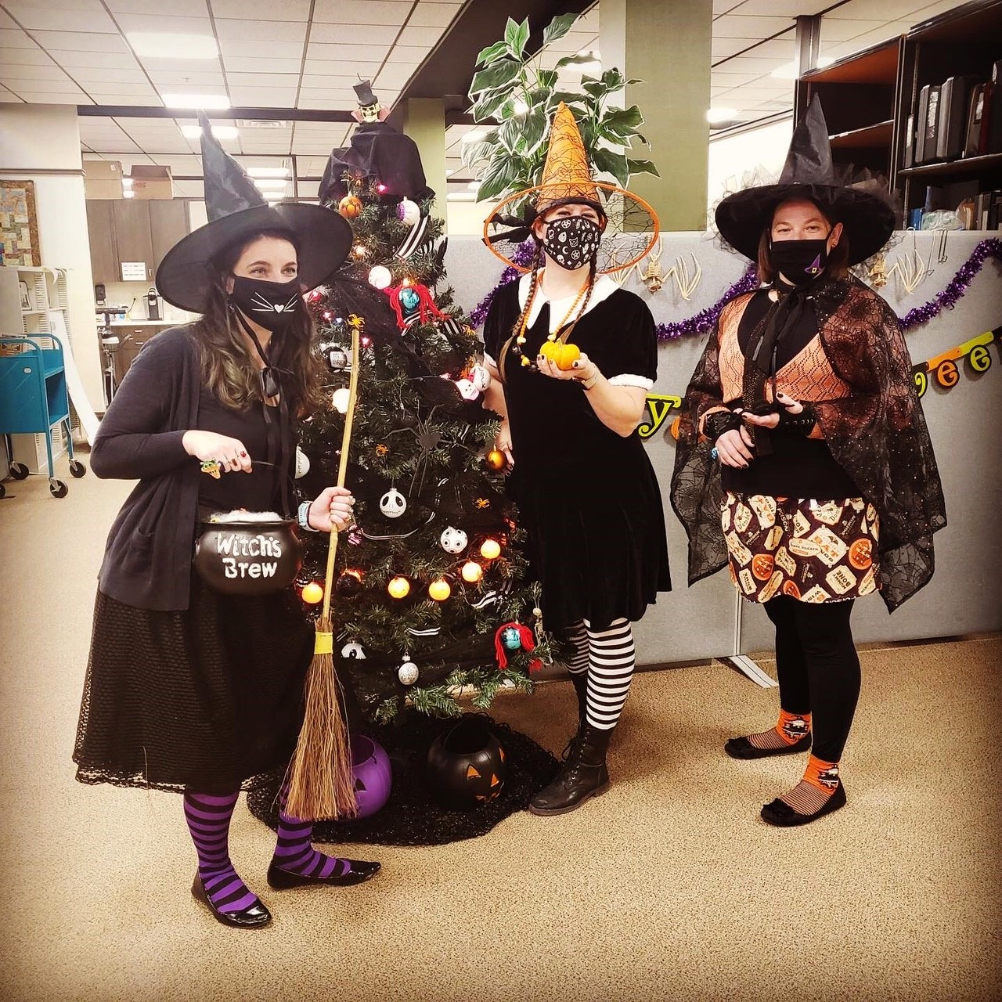

Thanksgiving
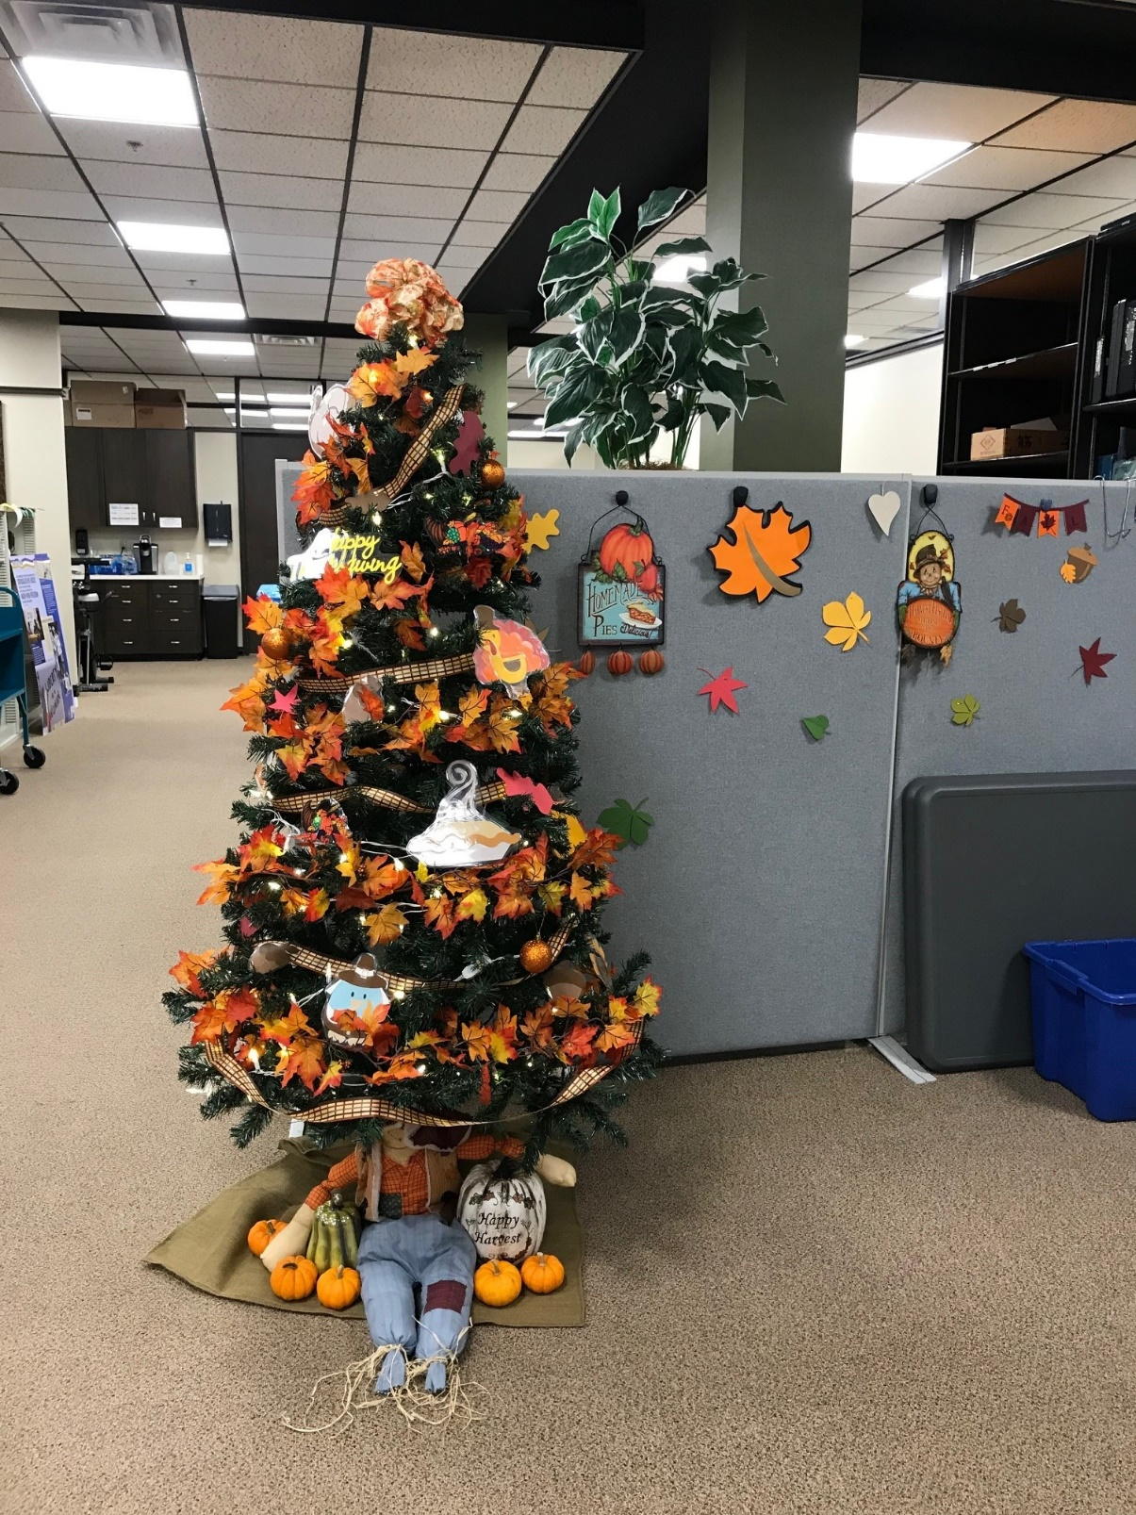

Valentine’s Day
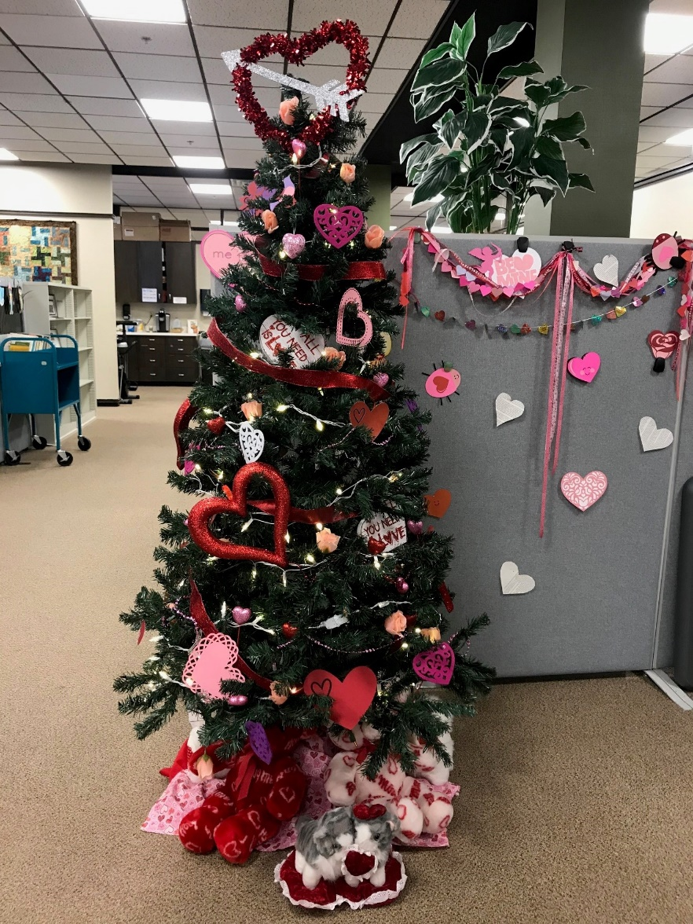
St. Patrick’s Day
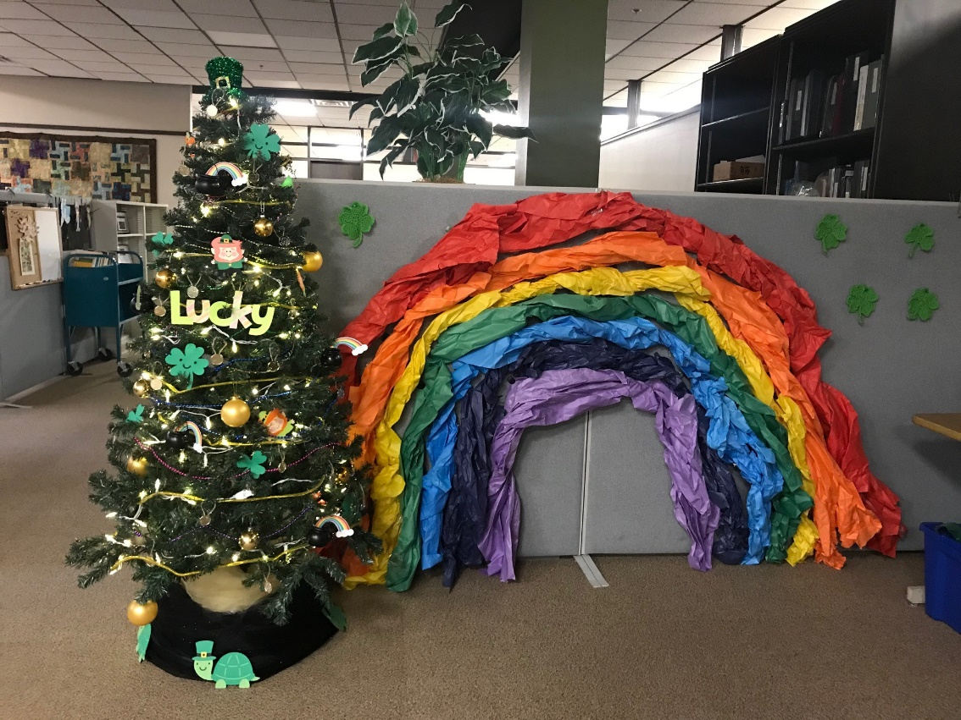
Easter
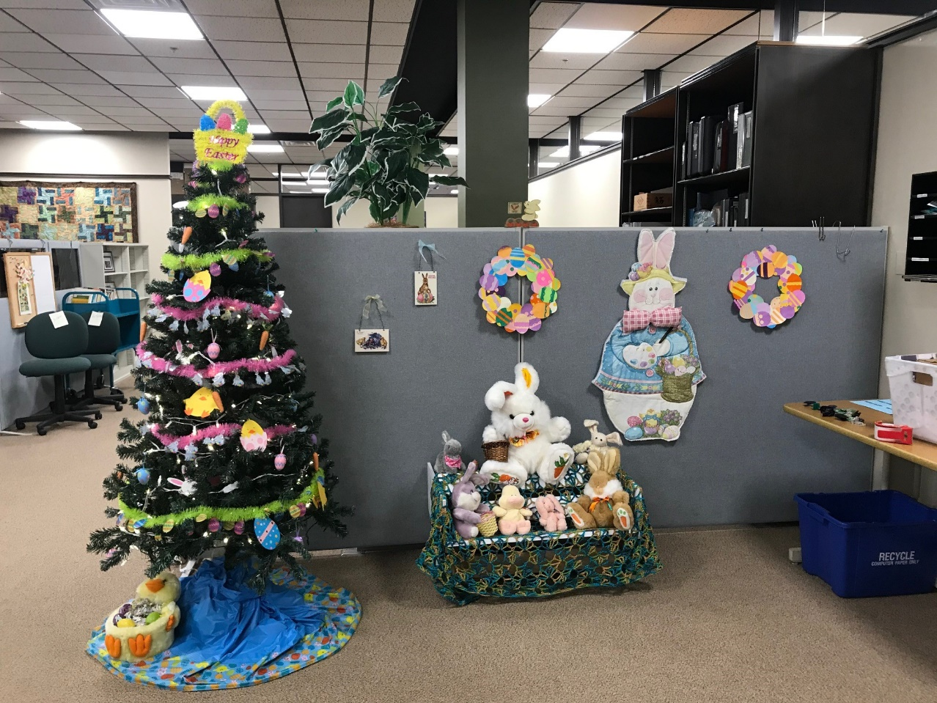
April Showers
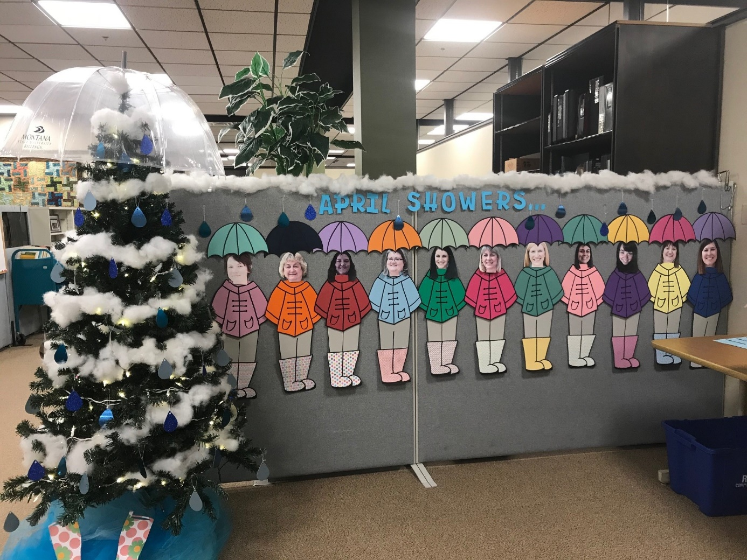
Slow, Long Board Game Series. We started the slow and long board game series with Chutes & Ladders, Yahtzee, and Candyland. During this time, we were only here one day a week. So, when you were in the office, you would take your turn, and sometimes, it could be multiple rolls that day. The winners of each game won a fun prize from the Dollar Tree.
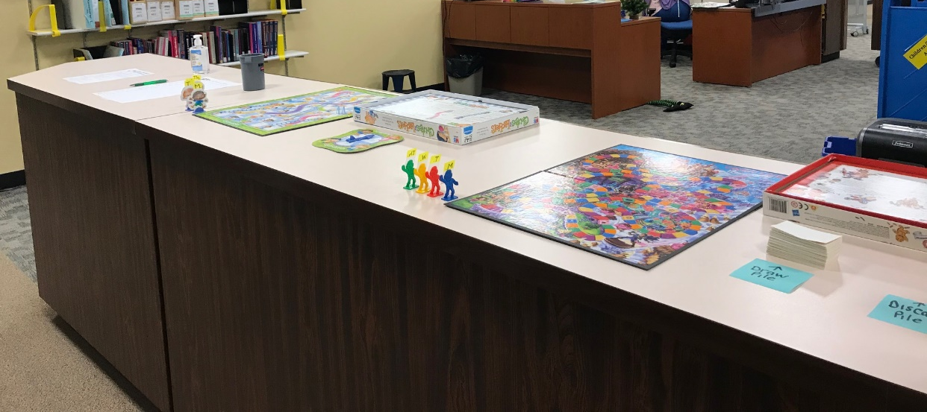
For round two, we played Monopoly and Scrabble. Now we are only in the office 2 times a week, so we have a rotating schedule of turns. And yes, Monopoly is still going.
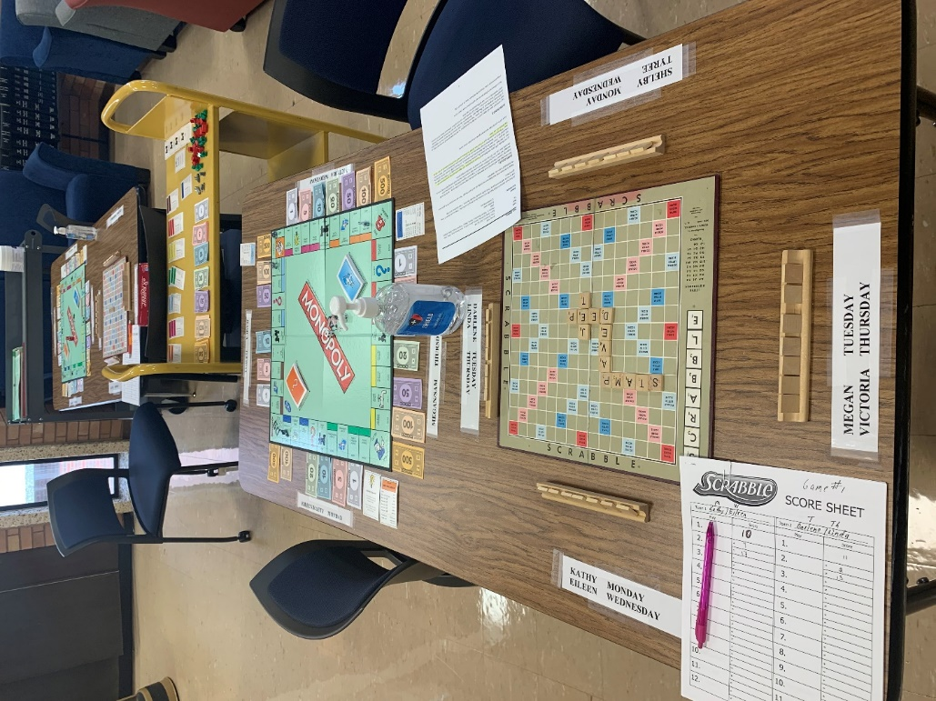

We are not done yet. Once again Jessica came up with a great idea for our mental wellness: March Forward: A Year of Feelings. It is a graph that Jessica and Sam created out of the emotions we have felt throughout the pandemic.
MARCH FORWARD
A Year of Feelings
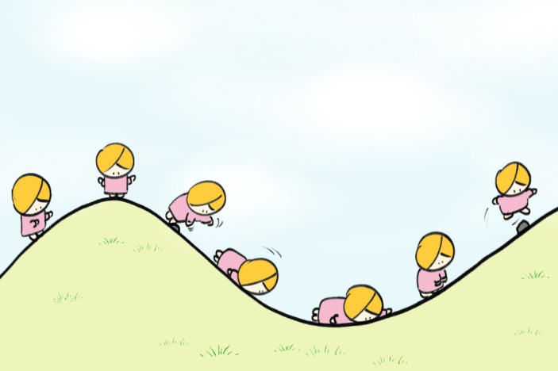
It’s been a year since the world as we knew it changed. With that, we have all felt a range of emotions. Reflecting on emotions while experiencing a situation is an important part of understanding ourselves as humans and recognizing the need to feel emotion.
Reflect back on each month and remember how you felt. Choose an answer (A-F) that best describes you during that month. We will then create a graph to show everyone’s emotions throughout the pandemic. Your answers will be anonymous.

A: Happy, Optimistic, Thankful
B: Creative, Inspired, Determined
C: Needy, Lonely, Pensive
D: Somber, Crushed, Heartbroken
E: Edgy, Stressed, Anxious
F: Frustrated, Disgusted, Doubtful

March 2020 ________________
April ________________
May ________________
June ________________
July ________________
August ________________
September ________________
October ________________
November ________________
December ________________
January ________________
February ________________
March 2021 ________________
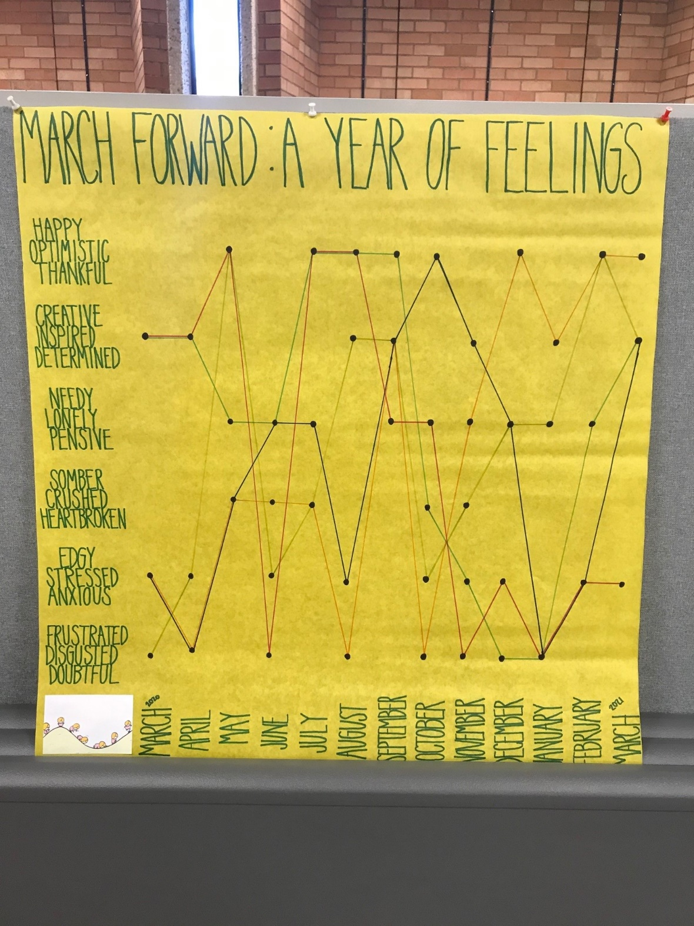

This has been a difficult year for all of us, and we are not out of the woods yet. However, we have been finding ways to cope. We have found ways to make each other laugh and smile through these dark days. There have been times that a team member asks for a positive pic or word to be said and the Teams chat lights up. We have become a stronger team throughout this scary time.

